Three phase

* A three phase system consists of three alternating voltages (or currents) of equal frequency and amplitude having a phase difference of 120 degrees with each other.

Advantages:

* G 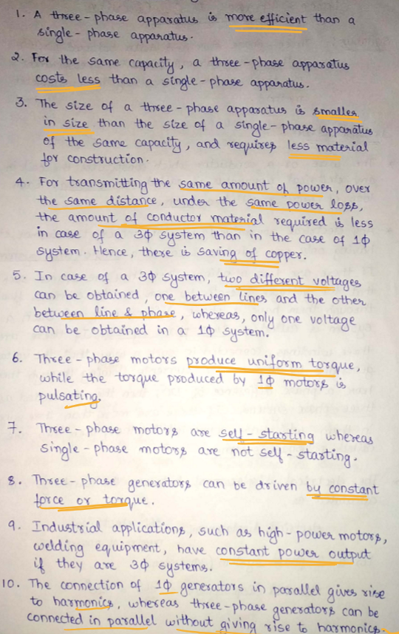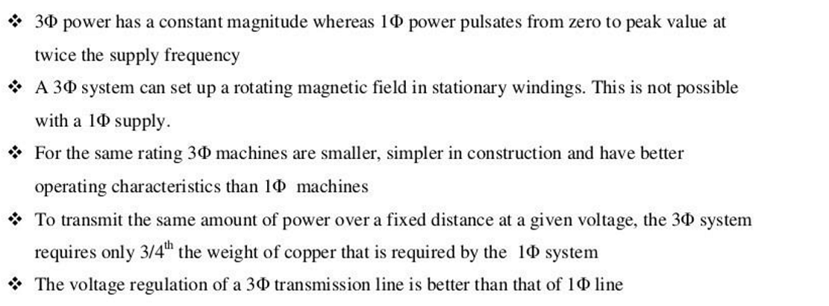

Machine that Generates Three-Phase Voltages

* It is called an alternator or synchronous generator.
* It mainly consists of a stator (stationary part) and a rotor (rotating part)
* Stator is the stationary outer part with slots on its inner periphery.
* These slots house the three-phase windings (conductors).
* Windings are arranged so that the EMFs induced in them are additive. They are displaced by 120° electrical from each other.
* Windings can be connected in star (Y) or delta (Δ) configuration.
* Rotor is that rotating inner part with permanent magnets or field windings.
* Field windings carry DC current to produce magnetic flux.
* If electromagnets are used, they create a rotating magnetic field.

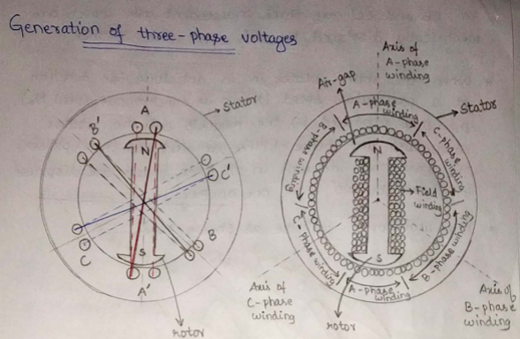

Principle of Generation

* Rotor rotates anticlockwise at synchronous speed (Ns).
* Magnetic flux cuts through stator conductors.
* By Faraday’s Law, EMFs are induced in stator windings.
* Since windings are spaced 120° apart, the EMFs are equal in magnitude and 120° out of phase with each other.
* 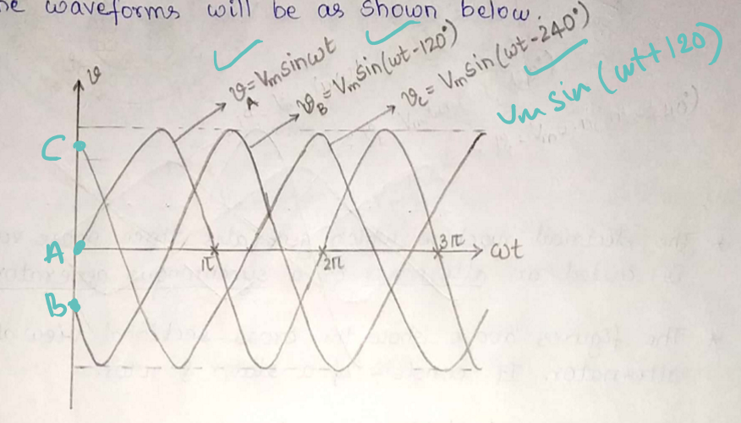 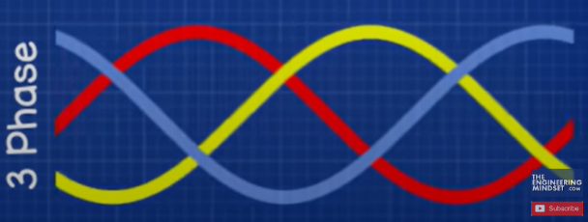
* RMS values of all phases are the same due to equal conductors in each winding.
* 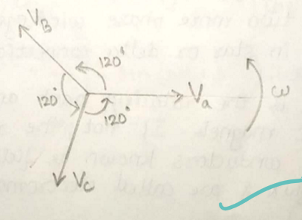
* Vb lags Va, Vc lags vb (both by 120)
* The length of each phasor represents maximum of peak value of each voltage.
* The three voltage phasors are displaced electrically by 120
* 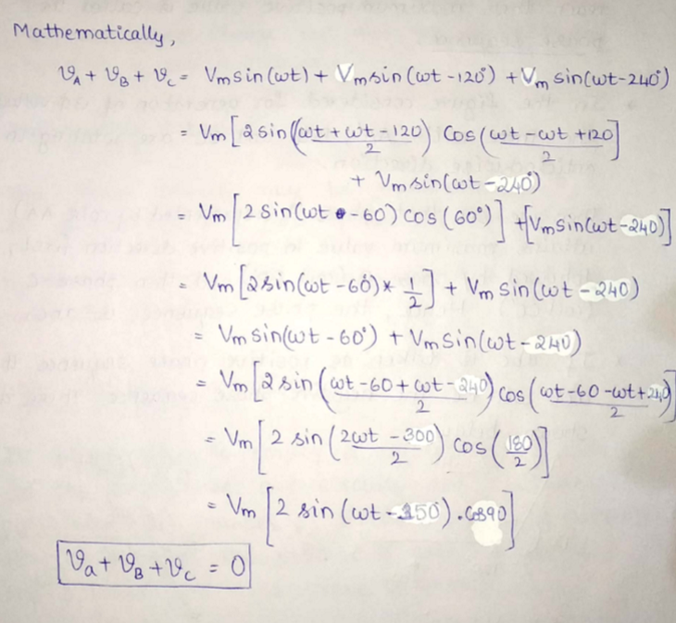

Concept of phase sequence:

* The order in which the voltages in phases reach their maximum positive value.
* In the figure, the coils AA′, BB′, and CC′ rotate in an anticlockwise direction.
* Phase A (AA′) → Phase B (BB′) → Phase C (CC′)
* This gives a positive phase sequence (abc).
* If the order becomes A → C → B, it's a negative sequence (acb)
* 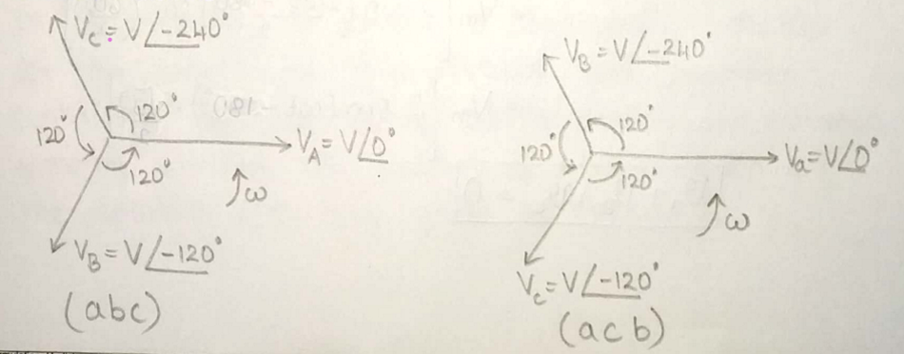

Significance of phase sequence

* For Static Loads:
* When a three-phase supply is given to a static load, current flows based on the phase sequence.
* Reversing the phase sequence changes the magnitude and phase angles of currents in the lines and the operation of the load.
* For Motors (Especially Induction Motors):
* If the phase sequence is changed, it changes the direction of rotation of the motor and alters the magnitude and angle of line and phase currents.
* Practical use: Motor direction control can be done by interchanging any two supply lines.

Balanced 3 phase supply:

* All three voltages have the same magnitude and the phase difference between them is exactly 120°.
* Eg: star or delta

Unbalanced 3 phase supply:

* The magnitudes of voltages are not equal and the phase differences are not 120°.

Star connection:

* One end of each of the three coils (windings) is connected to a common point.
* This common point is called the neutral point (N) or star point.
* The other ends of the coils are free and are connected to the external circuit, resulting in a 3 phase system connected in a star.
* Sometimes, a 4th wire is taken from the neutral point making a 3 phase 4 wires system.
* 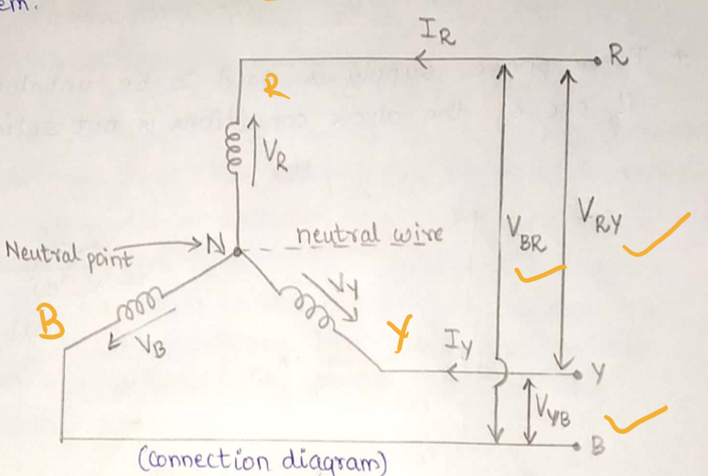
* Arrows in the diagram show the positive direction of EMFs and currents (from star point outward).
* The phase sequence is RYB and is taken positive.
* The voltage between any line and neutral point is called the line-to-neutral voltage of the phase voltage. It is represented as VR, VY, VB
* The voltage between two lines is called line-to-line or line voltage. It is represented as VRY, VYB, VBR
* VRY = VR-VY, VYB = VY-VB, VBR = VB-VR
* 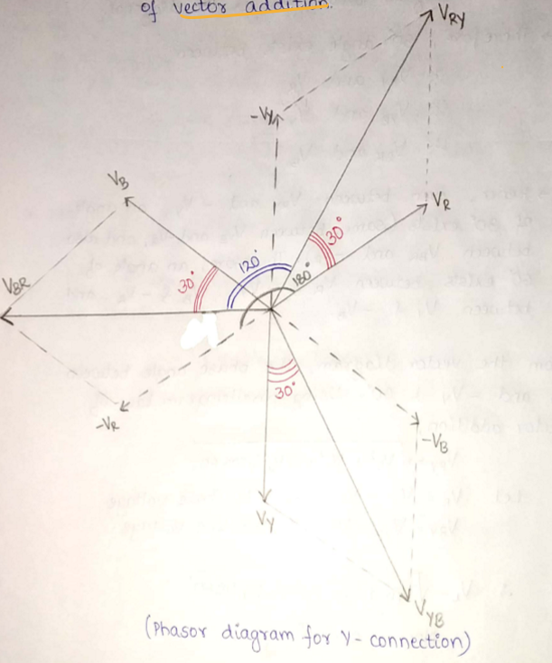\
* First, draw vr vy vb of ewual mag and with 120 phase diff with each other.
* Then, extend them in the opp dir as -vr, -vy, -vb
* To get VRY (VR+ (-VY)), use parallelogram low of vector addition.
* 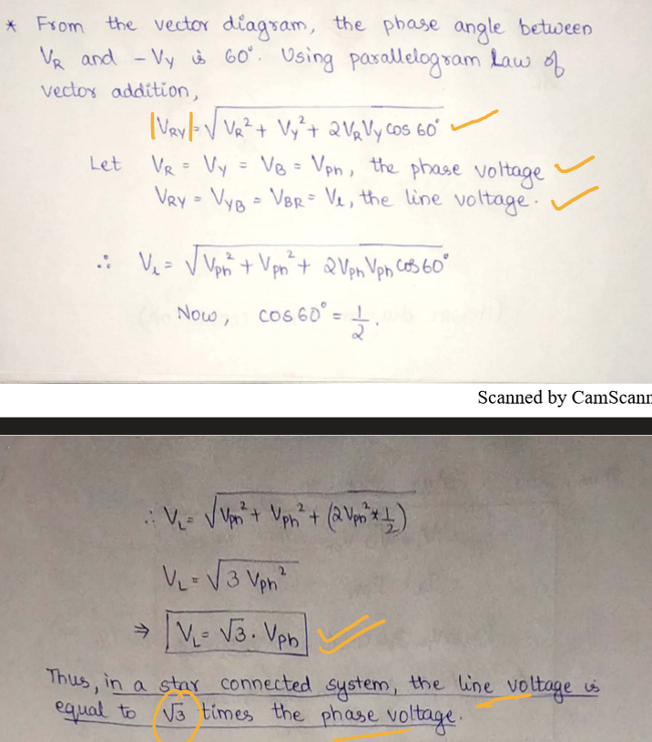
* 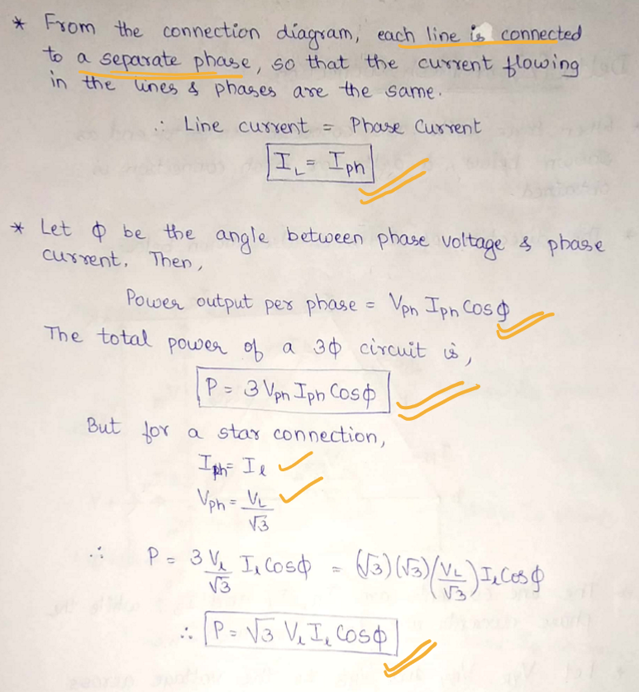

Delta/Mesh connection:

* The coils are connected end-to-end.
* 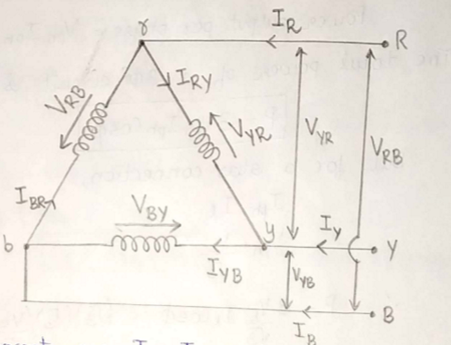

Transformer

* It is a static device which transfers power from one circuit to another, at the same of different voltage levels, without any change in frequency or power.
* Basic use of transformer is to increase/ decrease ac voltage.
* If the transformer increases the voltage level (vo>vs), step up transformer
* If the transformer decreases the voltage level (vo<vs), step down transformer
* If power transfer happens at the same voltage level (vo=vs), one-to-one transformer
* Works on the principle of EMI. Two coils linked magnetically but separated electrically, are used to transfer power.

Construction of transformer

* 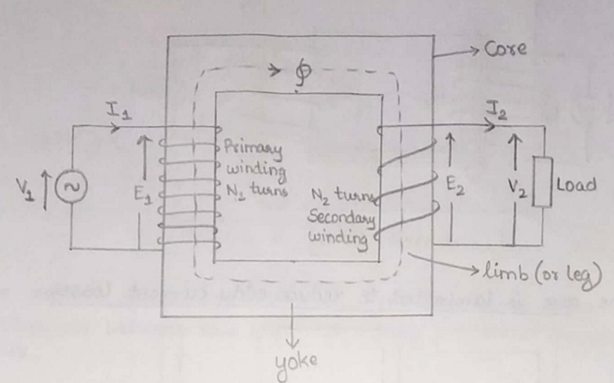
* Consists of two parts, the core and the winding.
* Core:
* Made of magnetic material (usually silicon steel or CRGO steel).
* Must have low reluctance or high permeability to carry magnetic flux.
* Composed of laminated sheets to reduce eddy current losses.
* Vertical parts = limbs, horizontal parts = yoke.
* Laminations are insulated from each other using varnish or paper.
* Large transformers use E, L, or I-shaped laminations joined together.
* 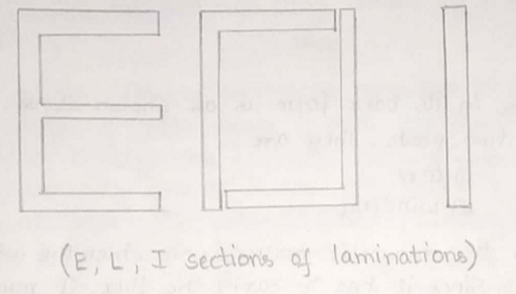
* Windings:
* Two windings: Primary (connected to the supply) and Secondary (connected to the load).
* Both are wound on the limbs of the core.
* Made of copper (low resistance), can be cylindrical or rectangular.
* Windings are insulated from each other and from the core to prevent short circuits.

Working Principle of a Transformer

* Principle: Based on mutual induction between two coils sharing a common magnetic flux.
* When an AC v1 is applied to the primary winding, it generates alternating magnetic flux ϕ in the core.
* This flux links with both primary and secondary windings and induces EMFs e1 and e2 respectively.
* 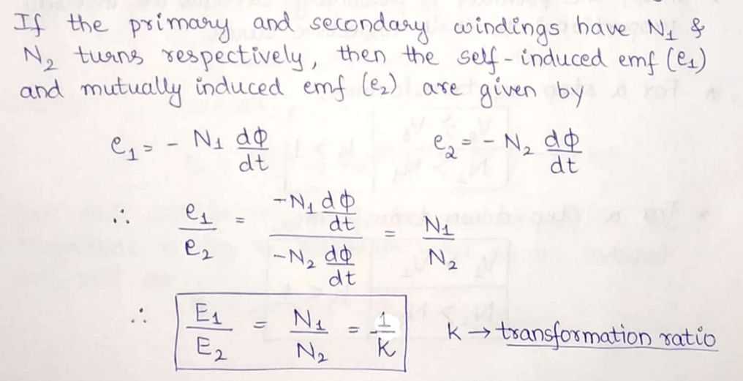
* If a load is connected to the secondary winding, current i2 flows through the load and v2 is the terminal voltage across the load.
* 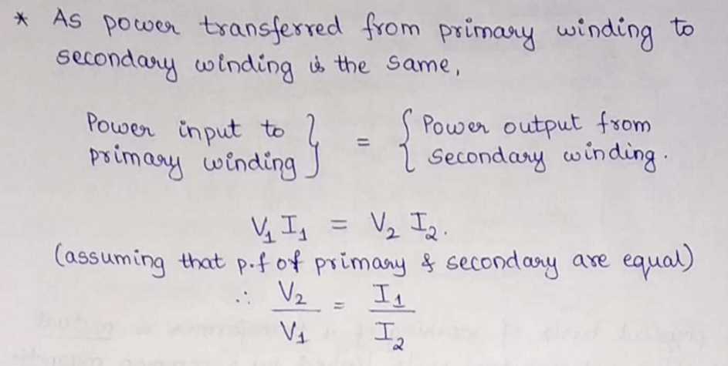
* 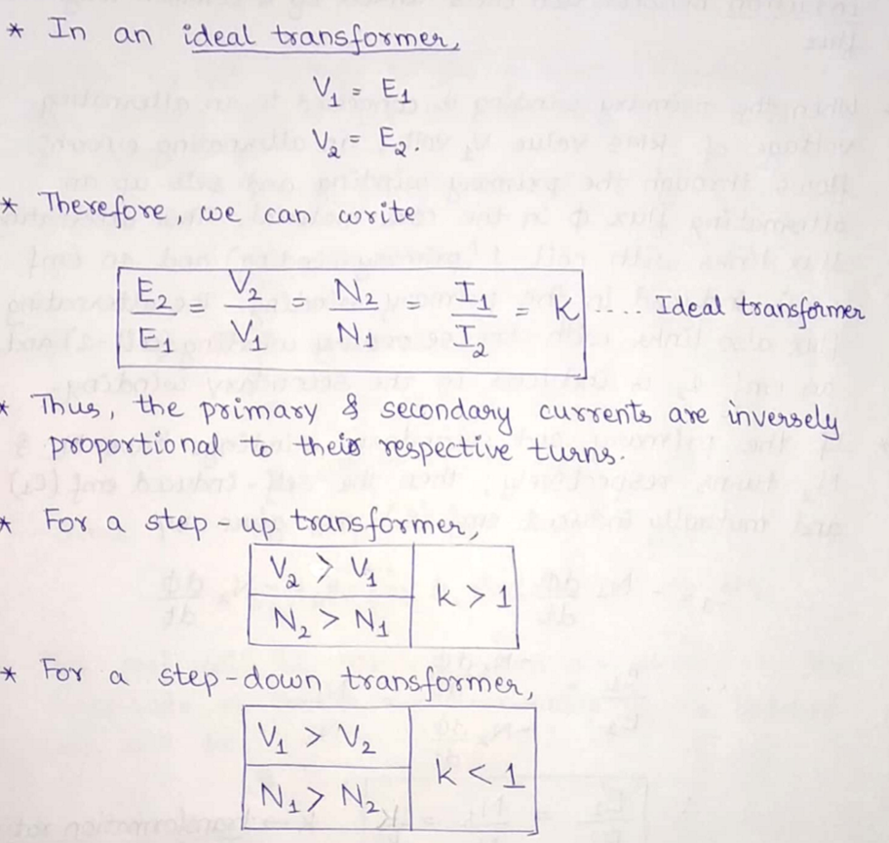

Emf equation:

* 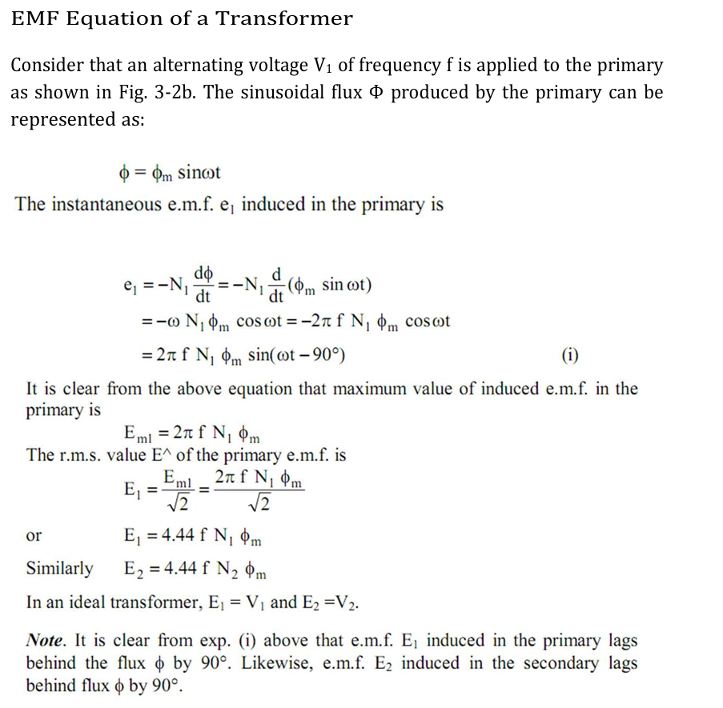
* 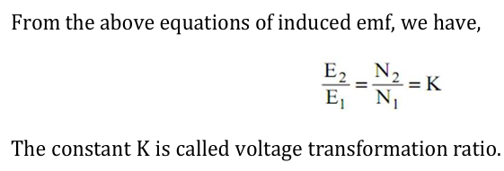

Ideal Transformer Assumptions

* No winding resistance (no copper loss).
* No leakage flux.
* No core losses (iron losses = 0).
* Infinite permeability (μᵣ) of the core.
* For an ideal transformer, the primary applied voltage V1 is same as the primary induced emf E1 as there are no voltage drops.

Ideal transformers on No-load Condition:

* Secondary current i2=0.
* Primary draws a small magnetizing current (Im) to set up magnetic flux ϕ.
* i1=Im, which lags supply voltage v1 by 90° (purely inductive).
* Flux ϕ is in phase with magnetizing current Im.
* It links both primary and secondary windings, inducing self and mutually induced emfs.
* EMFs:
* Due to Lenz’s Law, E1 and E2 are in anti-phase with V1 (180° apart) but equal in magnitude.
* E1=V1, but in opposite direction.
* E2's magnitude depends on turns ratio N2.
* 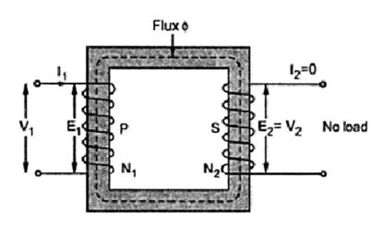
* 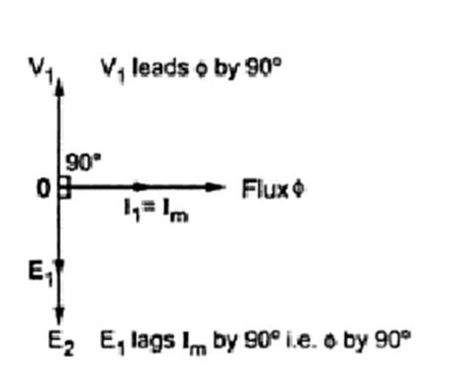
* 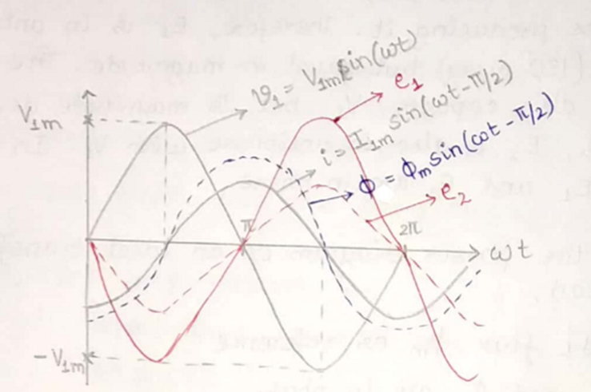

Transformers losses:

* Losses appear in the form of heat and produce an increase in temp and drop in efficiency.

Iron Loss (Wᵢ)

* Also known as core loss, it occurs in the iron core of the transformer due to alternating flux and consists of Eddy Current Loss (Wₑ) and Hysteresis Loss (Wₕ)
* Hysteresis Loss (Wₕ) occurs due to the continuous reversal of magnetic domains in the core. Can be minimized by using steel of high silicon content.
* Eddy Current Loss (Wₑ) is caused by circulating currents in the core due to changing magnetic flux. Can be reduced by using core of thin laminations.
* 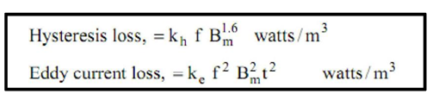

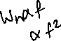

* Note: Since Bm, f, V, and t remain constant with voltage, iron loss is considered constant from no-load to full load. 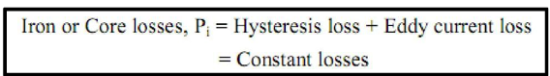

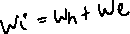

Copper Loss (Wcu)

* Due to ohmic resistance in primary and secondary windings.
* 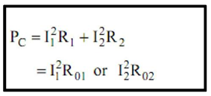
* Varies with load current i1,i2 hence it's a variable loss.

Total loss in transformer:

* 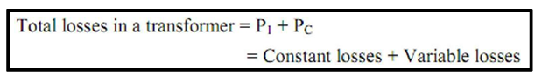

Transformer Efficiency (η)

* Definition: Efficiency of a transformer at a given load and power factor is the ratio of output power to input power.
* 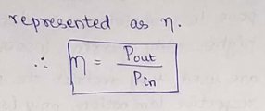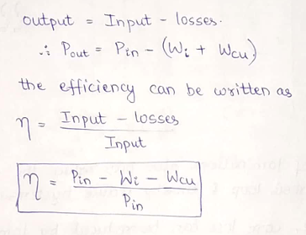

Condition for max efficiency

* 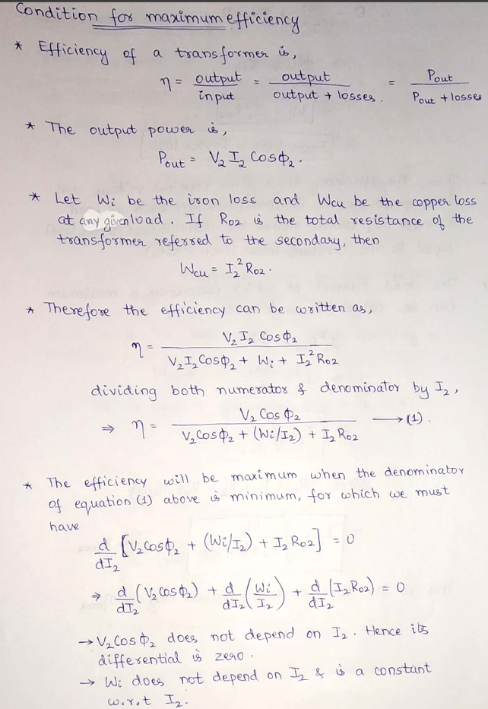 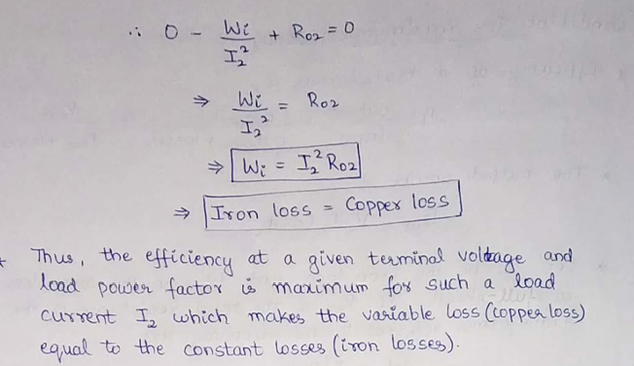
* 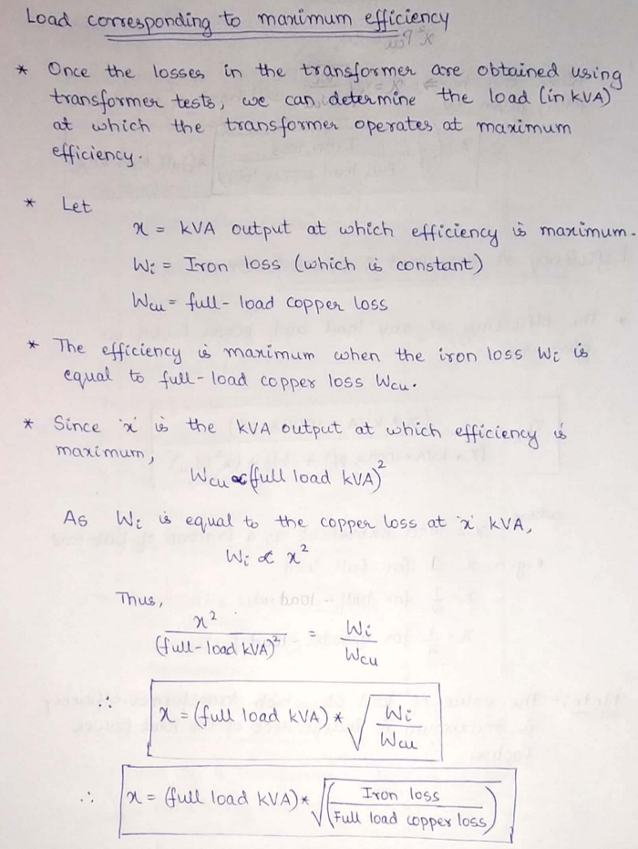 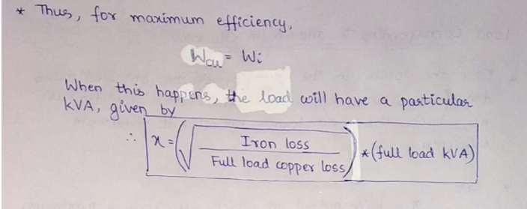
* 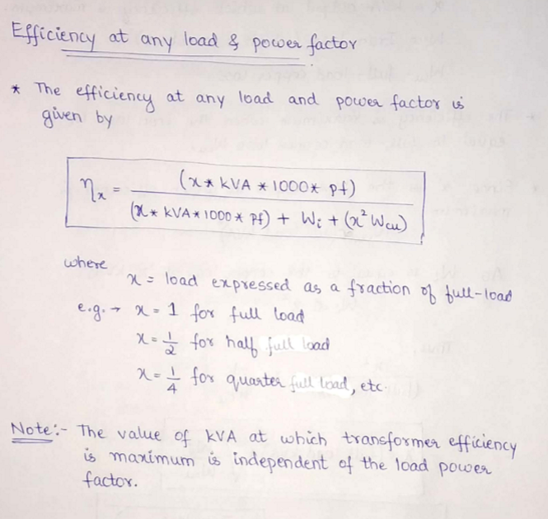
* 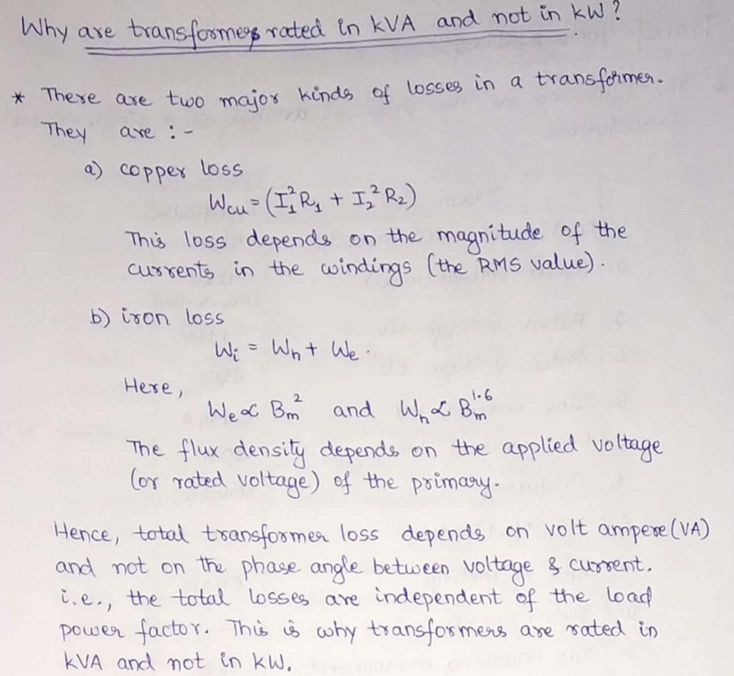
* 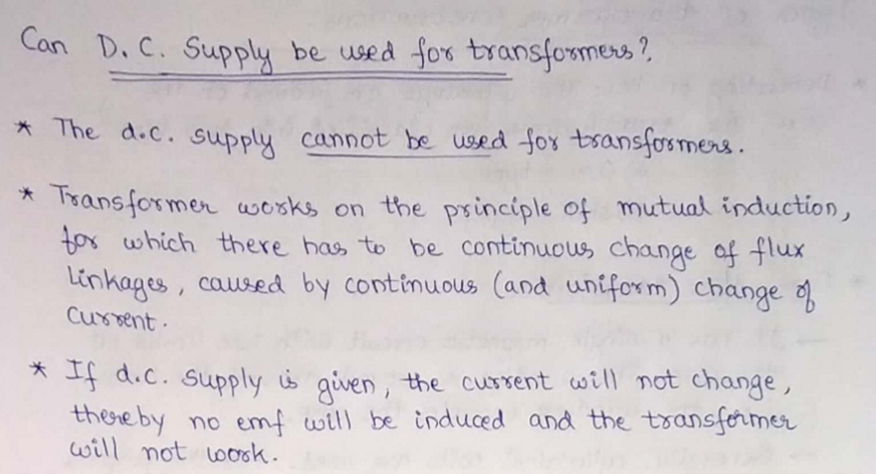

Transformer rating (voltage ampere rating)

* It is specified as the product of voltage and current.
* 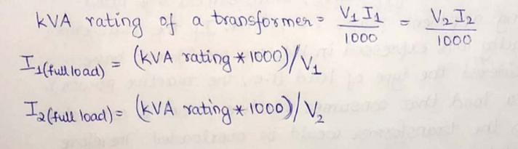

Types of transformer constructions

* Classification based on winding placement: Core-Type Transformer and Shell-Type Transformer

Core-Type Transformer

* Structure:
* Single magnetic circuit with two limbs.
* Windings are wound around the limbs, encircling the core.
* Winding Configuration:
* Uses cylindrical coils.
* Windings are interleaved to reduce leakage flux.
* Low voltage winding is closer to the core; high voltage winding surrounds it.
* Advantages:
* Better natural cooling due to exposed windings.
* Easier maintenance, top yoke can be removed.
* 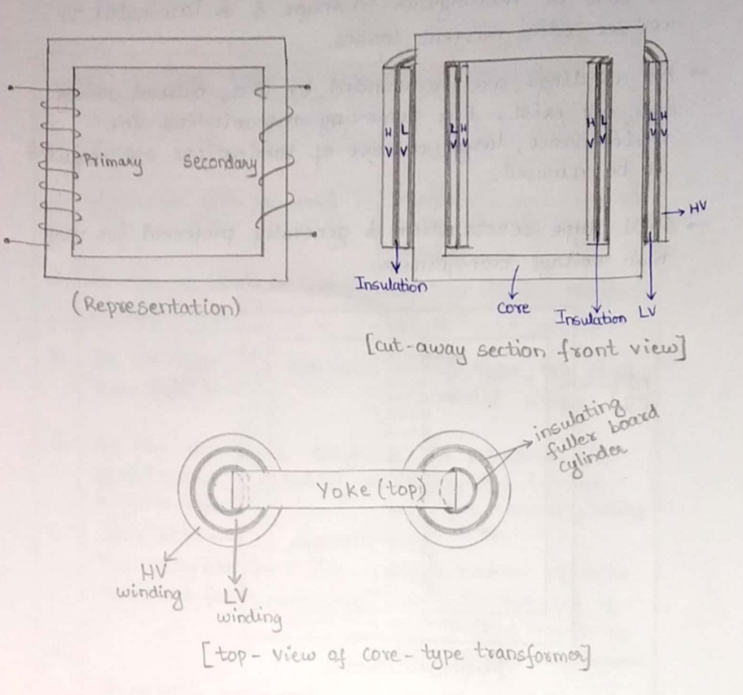

Shell-Type Transformer

* Structure:
* Double magnetic circuit with three limbs.
* Both primary and secondary windings are on the central limb.
* Winding Configuration:
* Uses multilayer disc-type or sandwich coils.
* LV coils placed at the top and bottom; HV coil is in between.
* Core & Maintenance:
* Rectangular laminated core reduces eddy current losses.
* Poor natural cooling as windings are surrounded by the core.
* Maintenance is harder as many laminations must be removed.
* Preferred Use:
* Suitable for very high voltage transformers.
* 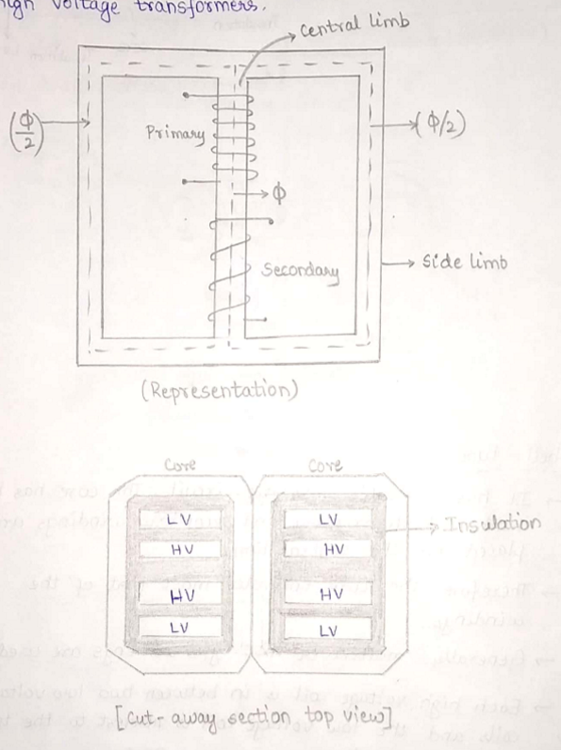

**Tabular Comparison (Core vs. Shell Type)**

| **Feature** | **Core Type** | **Shell Type** |
| --- | --- | --- |
| Winding placement | Encircles the core | Core encircles the windings |
| Coil type | Cylindrical | Multilayer disc/sandwich |
| Magnetic circuit | Single | Double |
| Number of limbs (1ϕ) | Two | Three |
| Cooling | More effective | Less effective |
| Maintenance | Easy coil removal | Difficult due to many laminations |
| Usage | Low voltage | High voltage |
| Mechanical protection | Less | Better due to enclosing core |